Program at a Glance
Wednesday, September 29
12:30–3:30 p.m.  3:00–5:00 p.m.  4:00–6:00 p.m.  7:00–10:00 p.m. | Ohio Statehouse fossil tour (see additional info on p. 2)  Registration  AESE executive team meeting  Welcome reception
Thursday, September 30
8:00 a.m.–9:00 a.m.  8:00 a.m.–5:00 p.m. | Breakfast on your own; Survey editors’ breakfast (see note below)  Registration
Session One
9:00 a.m.–9:15 a.m.  9:15 a.m.–11:30 a.m.  11:30 a.m.–1:30 p.m. | Opening remarks and welcome  Technical presentations  Luncheon and annual business meeting
Session Two
1:30 p.m.–4:00 p.m. | Technical presentations  Dinner on your own
Friday, October 1
8:00 a.m.–9:00 a.m.  8:00 a.m.–5:00 p.m. | Breakfast on your own; freelancers’ breakfast (see note below)  Registration
Session Three
9:00 a.m.–11:30 a.m.  11:30 a.m.–1:00 p.m. | Technical presentations  Lunch on your own
Session Four
1:15 p.m.–4:00 p.m.  6:00 p.m.–6:30 p.m.  6:30 p.m.–9:00 p.m. | Byrd Polar and Climate Research Center tour (see additional info on p. 2)  Cocktails  Awards banquet, keynote speech
Saturday, October 2
8:45 a.m.–5:00 p.m. | Field trip. Snacks and lunch provided by AESE.
Sunday, October 3
8:00 a.m.–10:00 a.m. | AESE executive team meeting

Survey editors’ and freelance editors’ breakfasts
Meeting attendees are invited to join their fellow editors for informal discussions about current challenges and opportunities relevant to their respective positions, and to share ideas for how to tackle them. Attendees will be responsible for their own breakfast; no meal is provided by AESE.

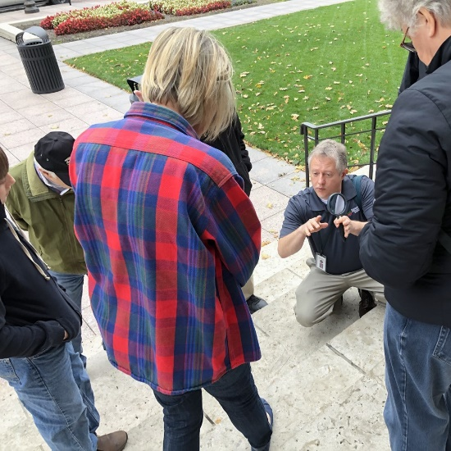
Ohio Statehouse fossil tour information
Mark Peter leads an Ohio Statehouse fossil tour
Ohio Geological Survey paleontologist Mark Peter will lead a tour to examine the variety of fossils found in the building stones of the Ohio Statehouse, including the fossiliferous Columbus Limestone. The tour will be fully accessible and include stops both inside the Statehouse and outside on the Capitol grounds.
The tour will be limited to a group size consistent with public health orders in place at the time of the event. The wearing of masks and social distancing will be encouraged. More information about special procedures to be followed will be sent to tour registrants in advance.

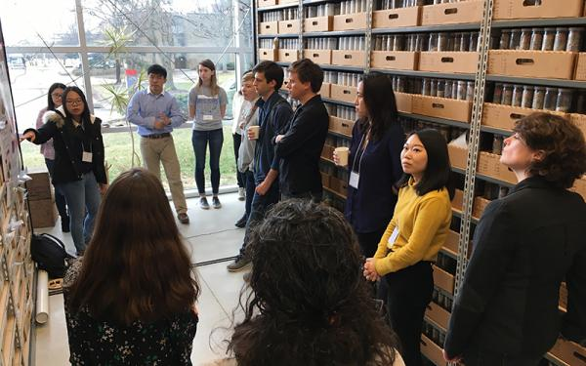
Byrd Center tour information
Image courtesy of Byrd Polar and Climate Research Center
Staff scientists of the Byrd Polar and Climate Research Center will lead a tour of this world-class research center. The tour will be limited to 45 individuals. Based on the pandemic’s status at the time, all protocols dictated by Ohio State University will be followed. More information about special procedures to be followed will be sent to tour registrants in advance.
Tour Agenda:
1:15 Board shuttle
1:30 Arrive at Polar Archives
2:20 Transition from Polar Archives to Byrd Center (about 0.4 mile)
2:30 Overview of Byrd Center, brief video, and tour of facilities
4:00 Depart Byrd Center

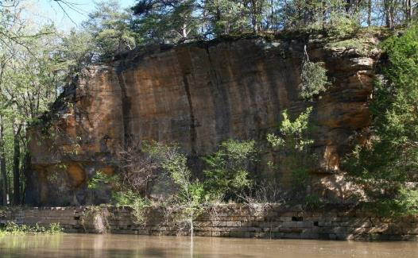
Geologic field trip information
Large outcrop at Blackhand Gorge State Nature Preserve
Join geologists Sam Hulett and Erika Danielsen, from the Ohio Geological Survey, as they lead a day-long exploration of Devonian and Mississippian geology in central Ohio. Stops will include visits to several parks to examine outcrops of the Devonian-age Columbus Limestone, Ohio Shale, and Berea Sandstone and the Mississippian-age Black Hand Sandstone, which is known for its striking scenic features. Transportation, lunch, and snacks will be provided by AESE. More information will be provided to registrants in advance.

